02.12.2026

Bacteriophage Lambda Genomunun NGS Verileri ile Referans Tabanlı RNA-Seq Analizi (Reference-Based RNA-Seq Analysis of Bacteriophage Lambda using NGS Data)

Istanbul Health And Technology University
Molecular Biology And Genetics, 3rd Grade
Bedriye GENCER

This study was conducted for educational purposes only.

1. Introduction
Objective: The aim of this study was to apply a quality control protocol to an RNA-seq dataset of unknown origin, remove detected low-quality reads and adapters via trimming, determine the taxonomic origin of the sequence through alignment, and identify the most highly expressed genes. All analyses were performed in silico.
Background: Bacteriophage Lambda serves as a fundamental model in molecular biology for understanding genomic structure and viral gene regulation (Casjens & Hendrix, 2015). Its small genome size offers an accessible model for sequencing and in silico analysis.

2. Methods
A subset dataset containing 10,000 sequences was obtained from the Bowtie2 (Langmead et al., 2018) training dataset. The following in silico bioinformatics pipeline was implemented:
Data Quality Control (QC): Raw RNA-seq data were analyzed using FastQC (v0.11.9) (Andrews, 2010) to examine Phred scores and adapter contamination.
Data Trimming: Reads with a quality score below 20 were designated as low quality. These reads and adapter sequences were removed using Trimmomatic (Bolger et al., 2014) with the parameters TRAILING:20 and MINLEN:15. This threshold was selected to preserve short fragments within the dataset.
Reference Genome Alignment: Cleaned reads were aligned to the Enterobacteria phage lambda reference genome (NC_001416.1), downloaded from NCBI, using the Bowtie2 algorithm.
Gene Expression Quantification: Aligned reads were counted at the gene level using featureCounts (Subread package) (Liao et al., 2013) and the reference GFF3 file to identify the products of the most highly expressed genes.
Visualization: Alignment depth and gene loci were visualized using IGV (Integrative Genomics Viewer) (Robinson et al., 2011; Thorvaldsdóttir et al., 2013).

3. Results
Initial FastQC analysis of the dataset revealed that the general quality scores of the reads were low, with mean values fluctuating around 16 (Figure 1). Following the trimming process, performed to increase data quality and remove unreliable reads, this value increased to approximately 20 (Figure 2).
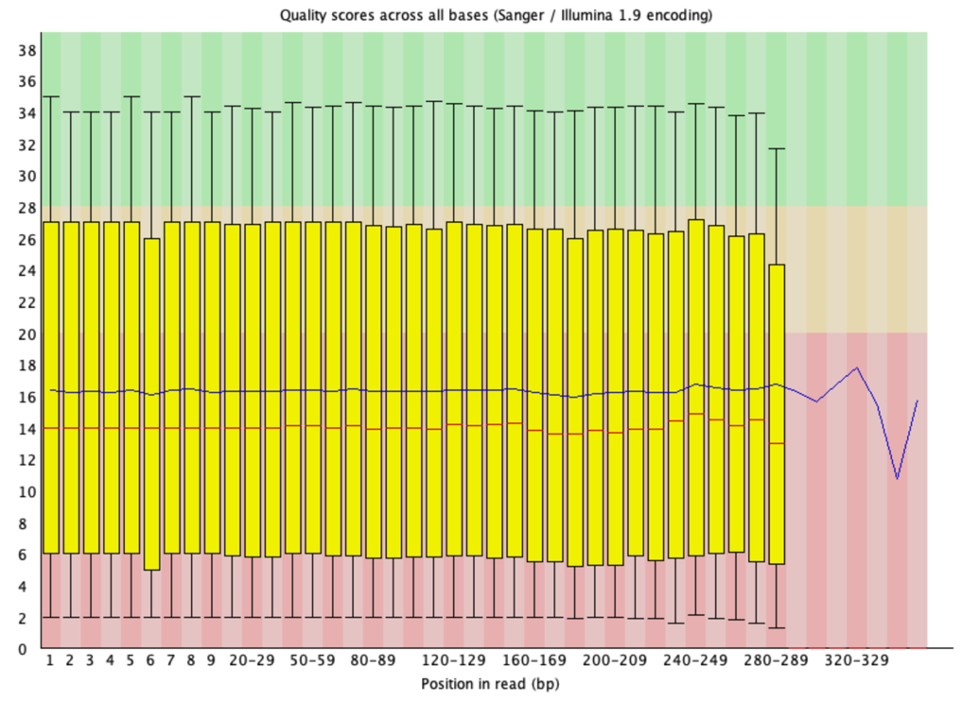
Figure 1. Quality control results visualized using the per-base quality score box plot generated by FastQC. The blue line indicates the mean quality score at each base position. The red zone represents low-quality calls; the yellow zone represents acceptable quality, and the green zone represents high-quality calls. It is observed that the quality scores of the reads are concentrated within the red and yellow zones.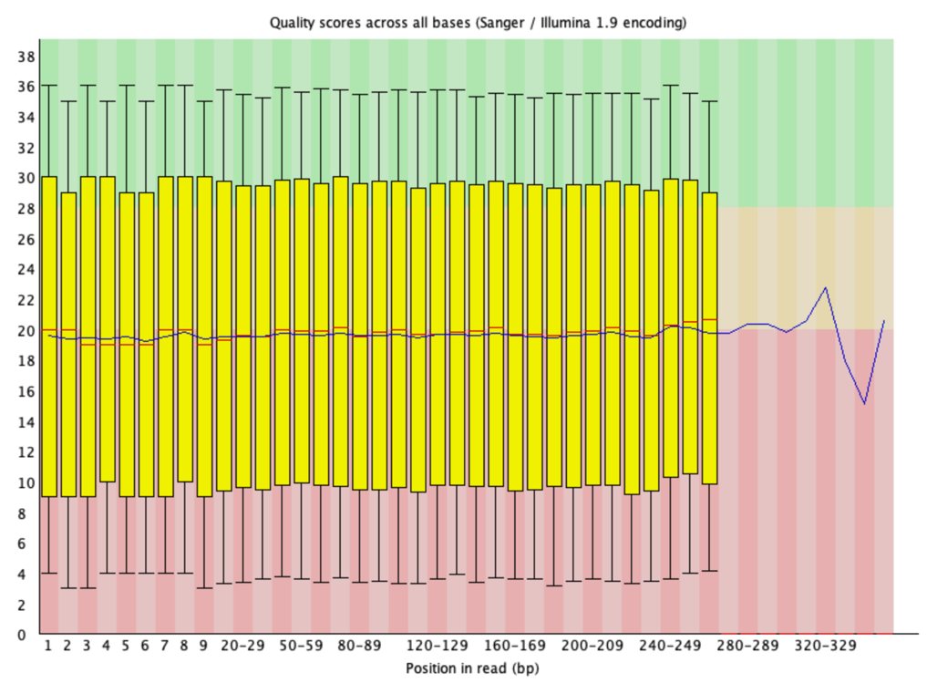
Figure 2. Box plot of per-base quality scores generated by FastQC following the trimming process for quality control. It is observed that the mean quality score, indicated by the blue line, increased to approximately 20; however, the quality scores of the reads remain concentrated in the red and yellow zones.
Following the workflow, the alignment rate to the reference Enterobacteria phage lambda genome was determined to be 98.48%. This high rate confirms that the dataset contains a high titer of the viral genome.
Gene count analysis identified the Tail Fiber Protein (ID: lambdap27), which forms the fibrous structures involved in the phage's attachment to the bacterium, as the most highly expressed gene across the genome. This was followed by the Tail Tape Measure Protein (ID: lambdap16), which determines the viral tail length, as the second most highly expressed gene. The read depth and alignment profile of the Tail Fiber Protein gene region are shown in Figure 3.
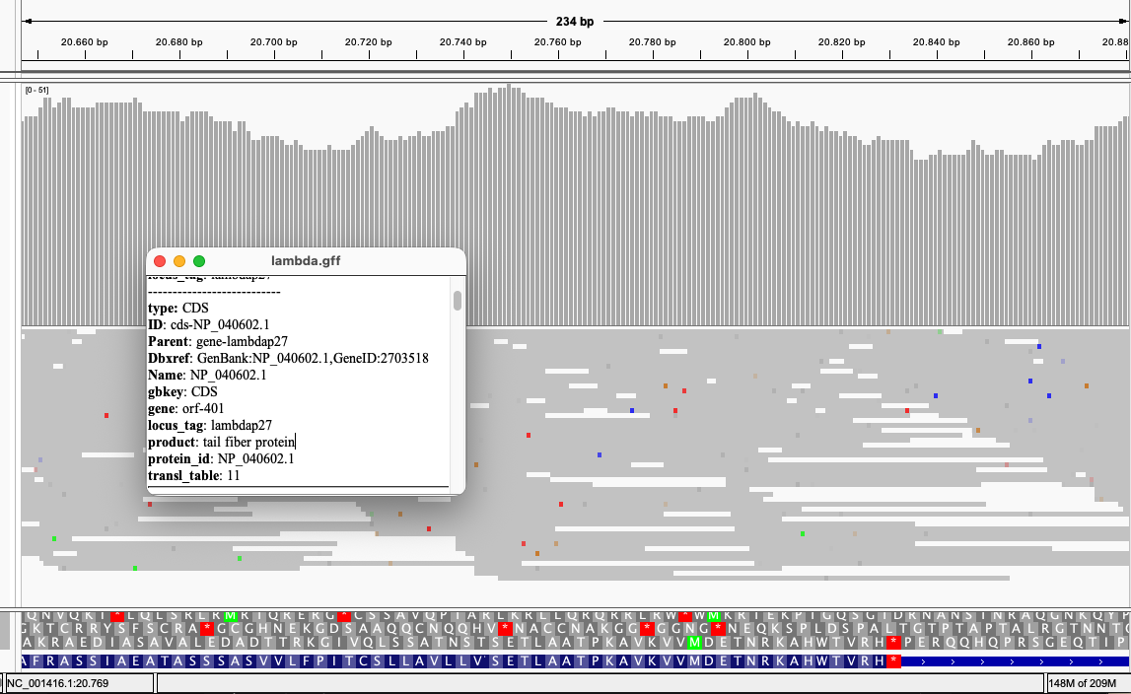

Figure 3. Snapshot obtained from IGV showing the Tail Fiber Protein gene region in the Lambda phage genome. The grey histograms indicate high read depth (coverage). The density in this region indicates the overexpression of structural proteins during the viral assembly phase.

4. Discussion
The observation of the highest expression in tail proteins suggests that the virus is in the late stage of the lytic cycle. The virus has likely completed DNA replication and is assembling its structural components prior to host cell lysis.
IGV examination revealed single nucleotide mismatches (colored lines) that do not align with the reference genome. This observation indicates that the analyzed viral strain may be evolutionarily divergent from the reference genome (NC_001416.1) or suggests potential mutations. Variant calling is recommended as a downstream analysis.

5. Skills Demonstrated
NGS Data Analysis: QC, Trimming, Alignment, Quantification.
Tools: FastQC, Trimmomatic, Bowtie2, Samtools, featureCounts, IGV.
Environment: Linux Command Line (Bash scripting), Package Management (Conda).
Biological Interpretation: Viral genome organization, gene expression profiling.

REFERENCES
Andrews, S. (2010). FastQC: a quality control tool for high throughput sequence data. Available online at: http://www.bioinformatics.babraham.ac.uk/projects/fastqc
Bolger, A. M., Lohse, M., & Usadel, B. (2014). Trimmomatic: a flexible trimmer for Illumina sequence data. Bioinformatics, 30(15), 2114-2120. https://doi.org/10.1093/bioinformatics/btu170
Casjens, S. R., & Hendrix, R. W. (2015). Bacteriophage lambda: Early pioneer and still relevant. Virology, 479-480, 310-330. https://doi.org/10.1016/j.virol.2015.02.010
Langmead, B., Wilks, C., Antonescu, V., & Charles, R. (2018). Scaling read aligners to hundreds of threads on general-purpose processors. Bioinformatics, 35(3), 421-432. https://doi.org/10.1093/bioinformatics/bty648
Liao, Y., Smyth, G. K., & Shi, W. (2013). featureCounts: an efficient general purpose program for assigning sequence reads to genomic features. Bioinformatics, 30(7), 923-930. https://doi.org/10.1093/bioinformatics/btt656
Robinson, J. T., Thorvaldsdóttir, H., Winckler, W., Guttman, M., Lander, E. S., Getz, G., & Mesirov, J. P. (2011). Integrative genomics viewer. Nat Biotechnol, 29(1), 24-26. https://doi.org/10.1038/nbt.1754
Thorvaldsdóttir, H., Robinson, J. T., & Mesirov, J. P. (2013). Integrative Genomics Viewer (IGV): high-performance genomics data visualization and exploration. Brief Bioinform, 14(2), 178-192. https://doi.org/10.1093/bib/bbs017

